Introduction to Cloud Computing

Module-1 Overview of cloud Computing

Task-1 Sign up for a free AWS or Azure account and log in to the Management Console. Take a screenshot of your dashboard showing your name or email in the top bar.
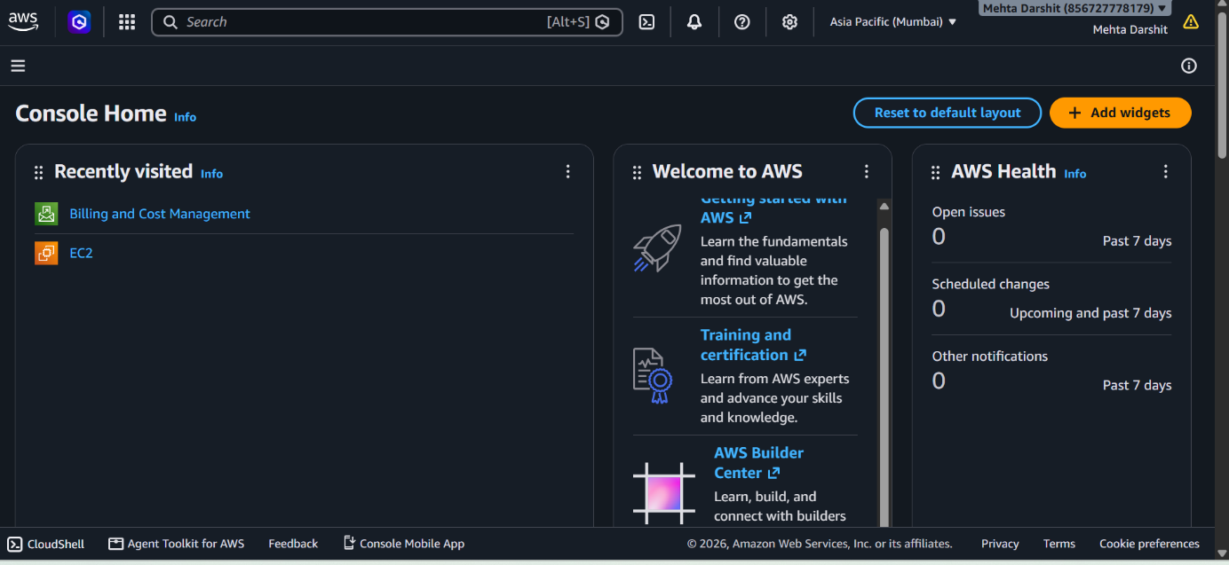
Task-2 In the AWS or Azure Management Console, locate and list 5 key services (such as Compute, Storage, Database, Networking, Analytics). For each, write one line describing what it does and name one real app (like Instagram, Zomato, Flipkart) that could use it.

Category | AWS Service | What it does | Example app
Compute | Amazon EC2 | Provides virtual servers to run applications and backend code. | Instagram could use it to run its application servers.
Storage | Amazon S3 | Stores files such as images, videos, documents, and backups in the cloud. | Flipkart could use it to store product images.
Database | Amazon RDS | Provides managed relational databases for storing and querying structured application data. | Zomato could use it to store restaurant and order information.
Networking | Amazon VPC | Creates a secure, isolated network environment for cloud resources and controls how they communicate. | Netflix could use it to securely connect its application servers and databases.
Analytics | Amazon Redshift | Analyzes large amounts of data quickly for reporting, business intelligence, and decision-making. | Amazon could use it to analyze customer purchasing and sales data.
Task-3 Use the search bar in your AWS or Azure Console to find the S3 (AWS) or Blob Storage (Azure) service. Write down the steps you took to locate it and describe in 2-3 lines how a music app like Spotify could use this service to store user-uploaded files
Steps to locate Amazon S3 in the AWS Console
- Sign in to the AWS Management Console.
- Find the Search bar at the top of the page.
- Type S3 into the search bar.
- Select S3 from the search results to open the Amazon S3 service page.
How Spotify could use S3
A music app like Spotify could use Amazon S3 to store user-uploaded audio files, such as songs or podcasts. S3 can securely store large numbers of files and make them available to the app when needed.
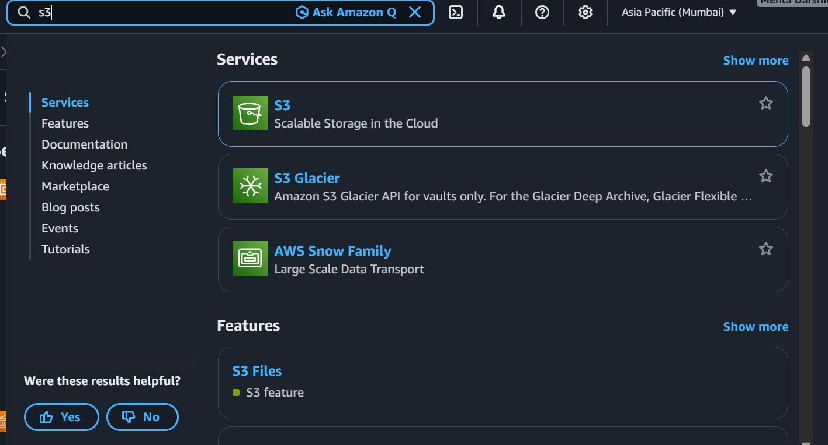
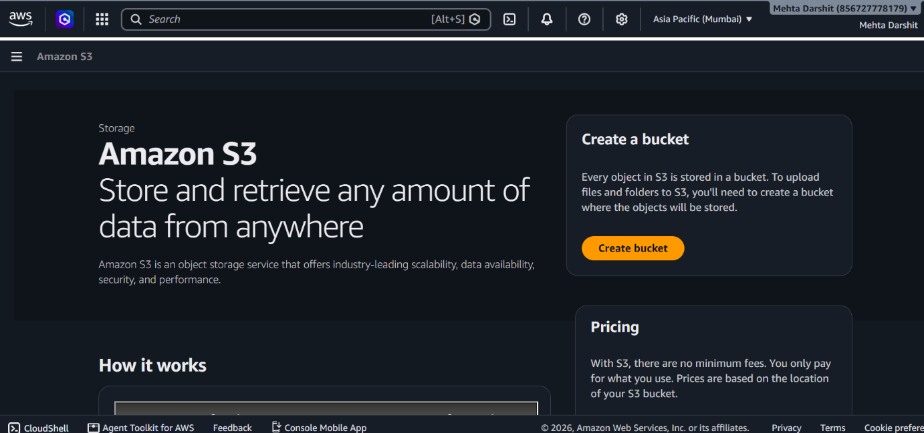
Task-4 Pick one key characteristic of cloud computing (on-demand self-service, broad network access, resource pooling, rapid elasticity, or measured service) and explain, in your own words, how it benefits users of a popular app you use daily (e.g., Paytm, BookMyShow, IRCTC). Think about how these apps handle sudden spikes in users or data.

Rapid Elasticity
Rapid elasticity means a cloud service can quickly increase or decrease computing resources based on demand. For an app like BookMyShow, this is useful when a popular movie or event releases and thousands of users try to book tickets at the same time. The cloud can provide extra resources during the rush and reduce them when traffic returns to normal, helping the app stay fast and reliable.

